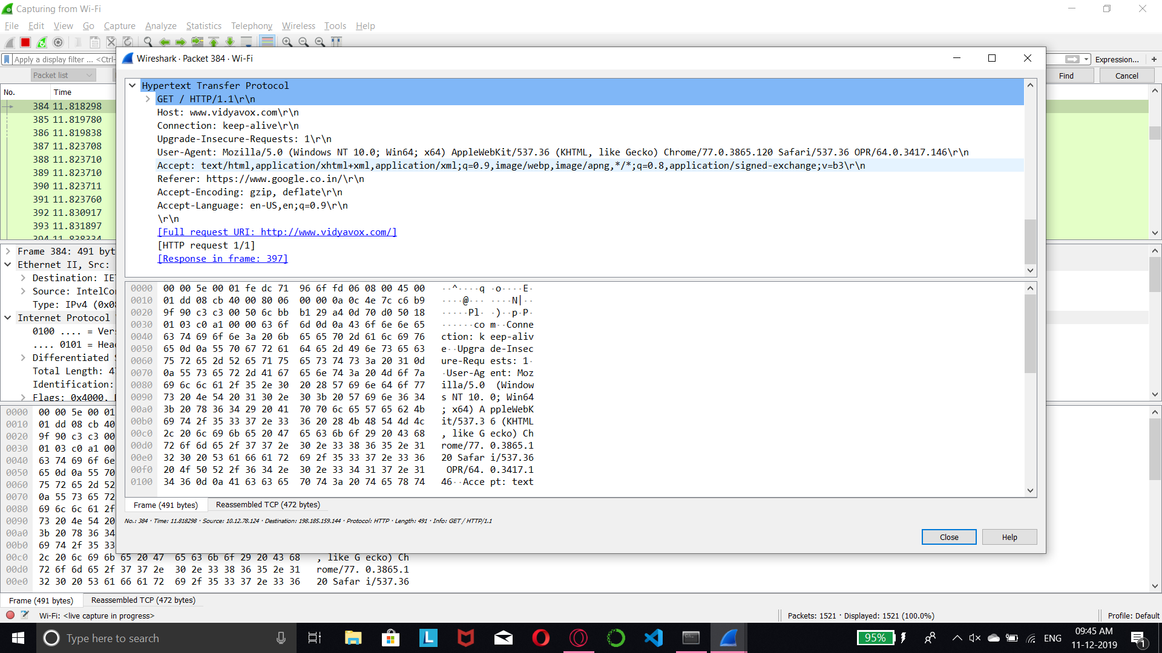
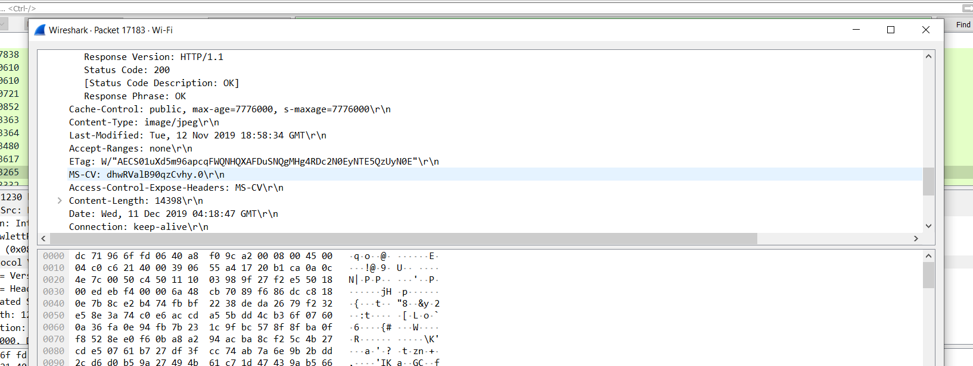
1)

2)

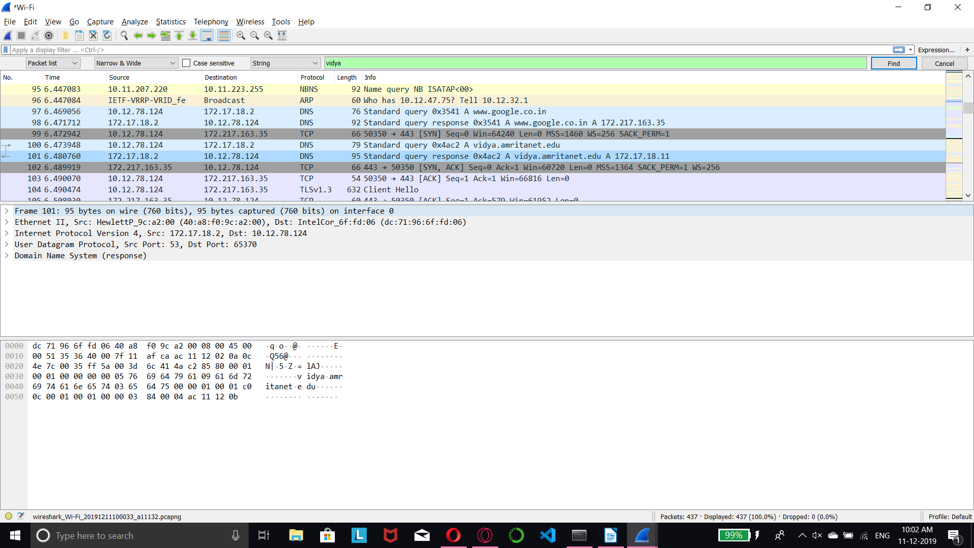

3)
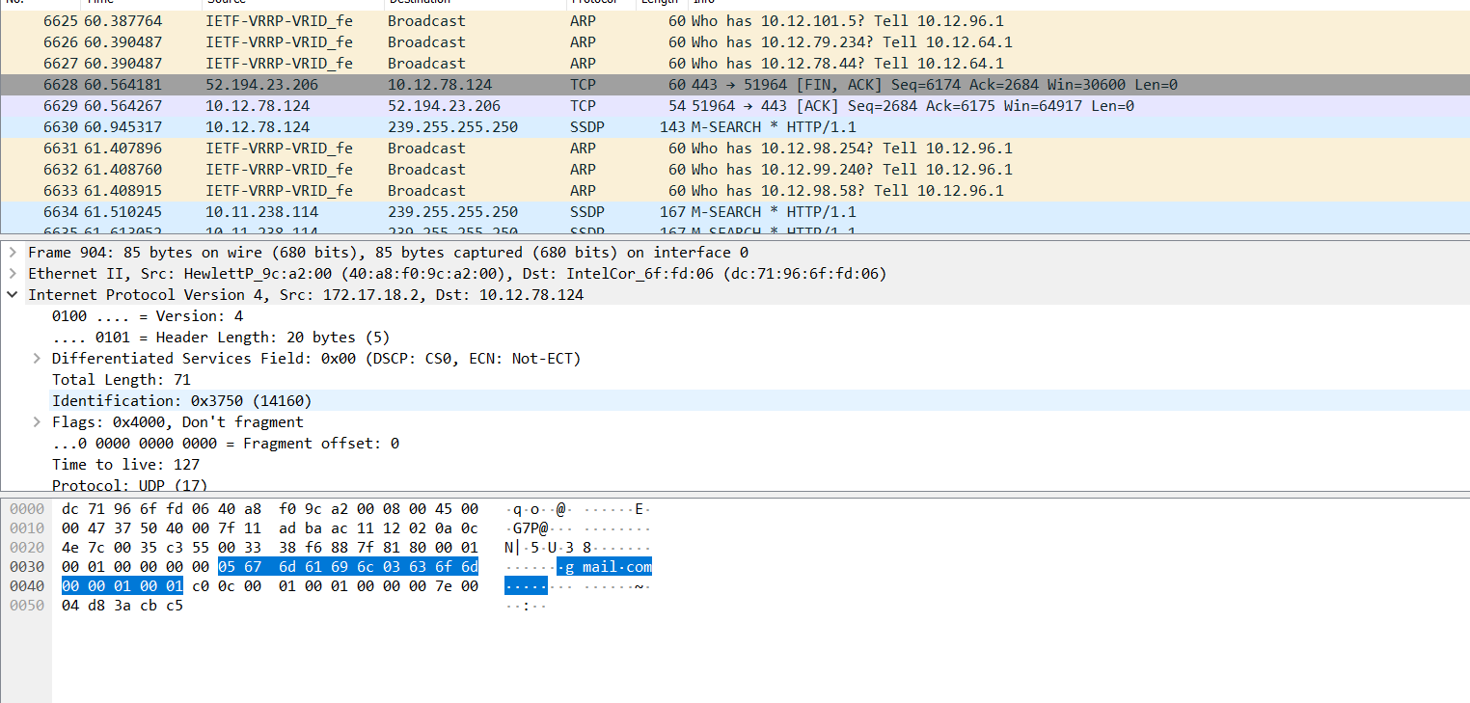
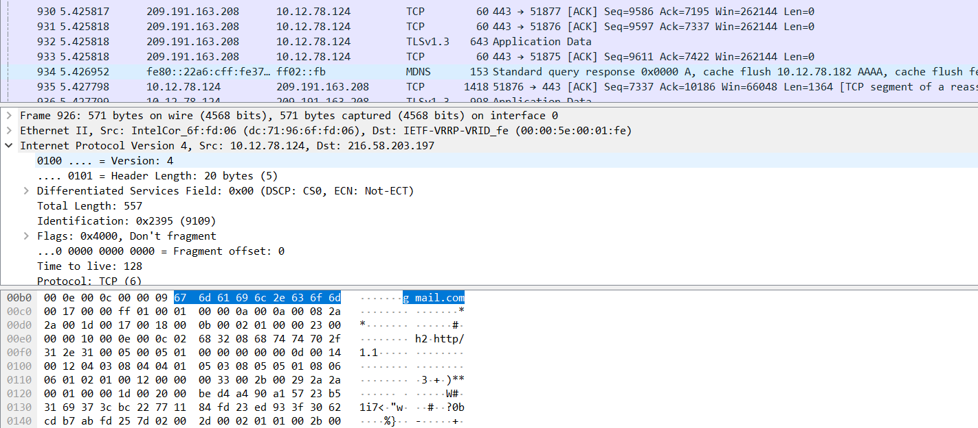

Average requests sent = 926 – 904 = 22 + 1 = 23 requests

4)

5)

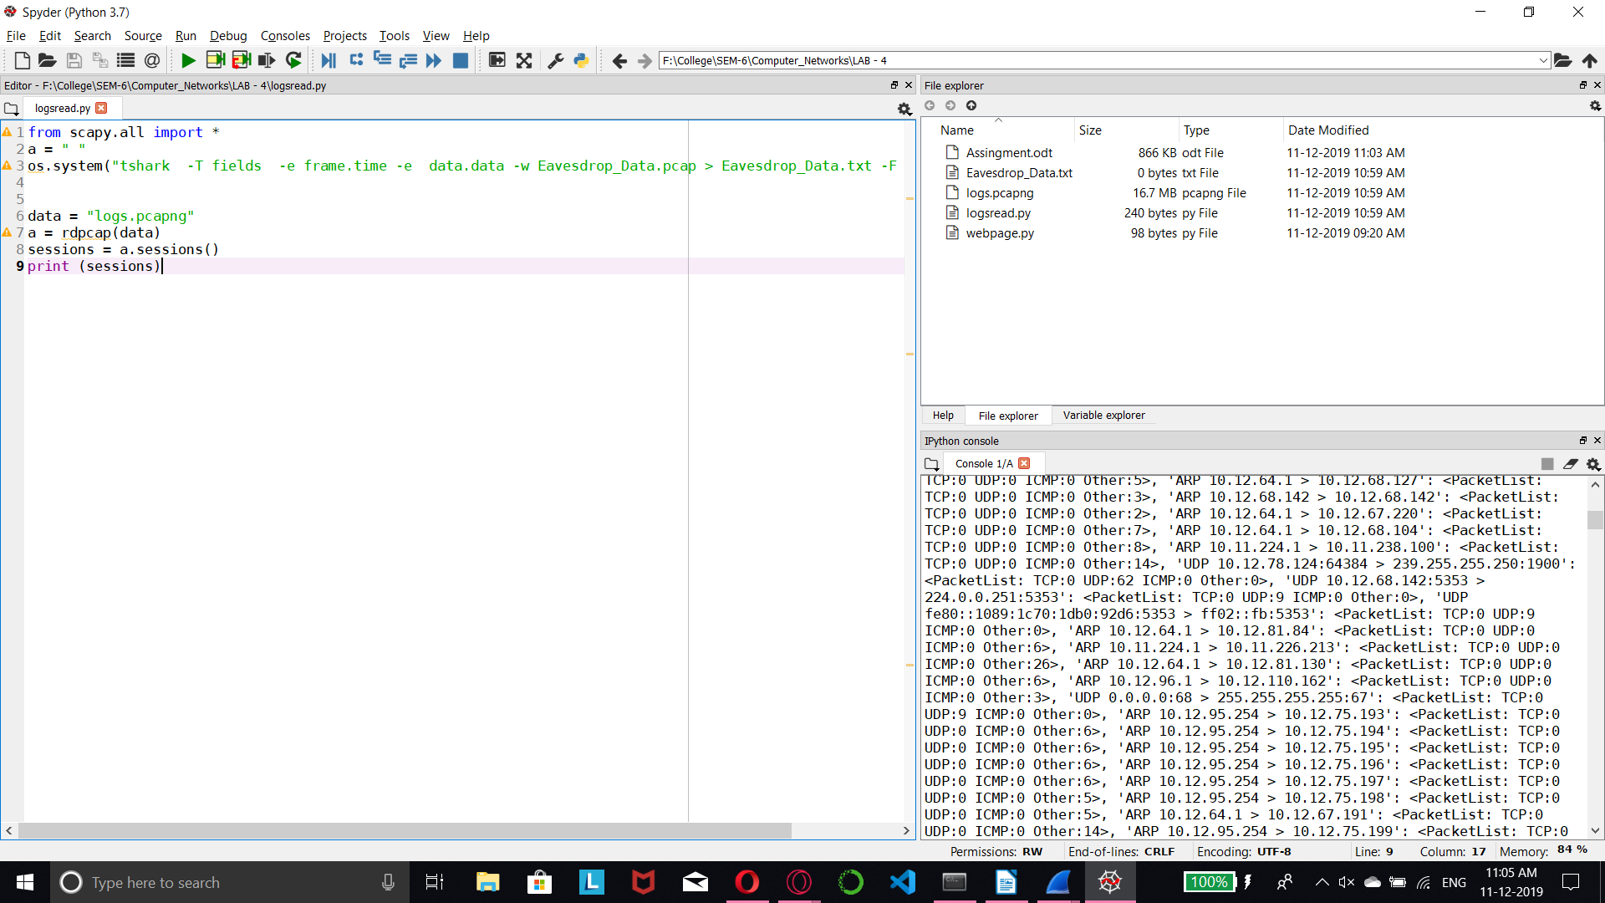

from scapy.all import *
a = " "
os.system("tshark -T fields -e frame.time -e data.data -w Eavesdrop_Data.pcap > Eavesdrop_Data.txt -F pcap -c 1000")

data = "logs.pcapng"
a = rdpcap(data)
sessions = a.sessions()
print (sessions)

